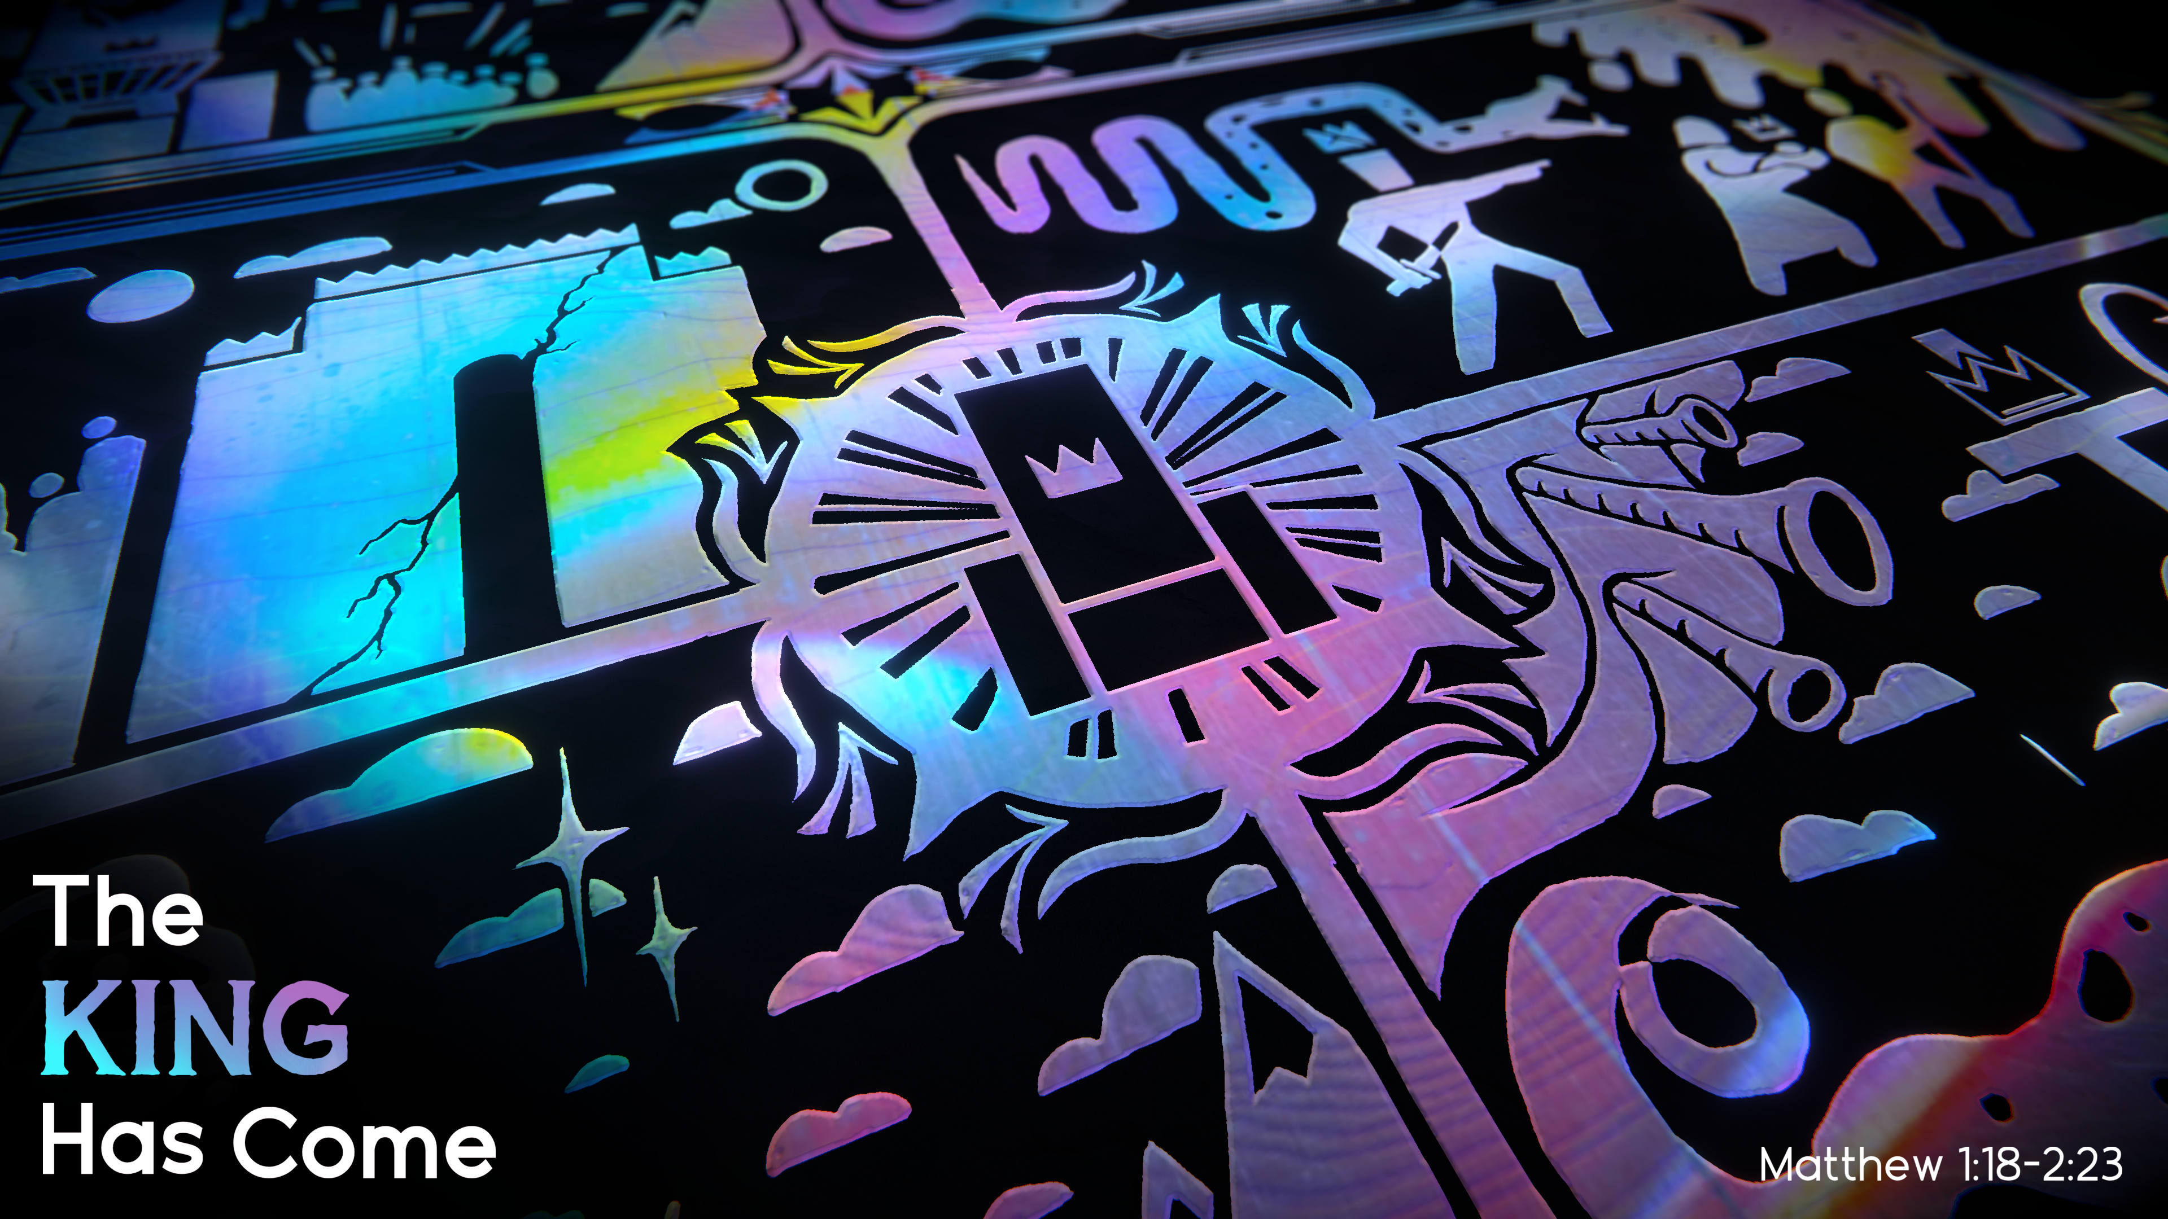
THE KING HAS COME
TRUE WORSHIP, PART 1
Matthew 2:1-6
Pastor Hayden Thomas • Compass Bible Church Hill Country • October 30, 2022 • Msg. 22-40

Matthew 2:1-6
1 Now after Jesus was born in Bethlehem of Judea in the days of Herod the king, behold, wise men from the east came to Jerusalem, 2 saying, “Where is he who has been born king of the Jews? For we saw his star when it rose and have come to worship him.” 3 When Herod the king heard this, he was troubled, and all Jerusalem with him; 4 and assembling all the chief priests and scribes of the people, he inquired of them where the Christ was to be born. 5 They told him, “In Bethlehem of Judea, for so it is written by the prophet: 6 “ ‘And you, O Bethlehem, in the land of Judah, are by no means least among the rulers of Judah; for from you shall come a ruler who will shepherd my people Israel.’ ” (ESV)

1. Take ______________________________ (vv.1-2)

2. Joyfully ____________________________ (vv.2-3)

3. Act _______________________________ (vv.4-6)

Application Questions
These questions are provided for your further study and application of today’s sermon. Thoughtfully writing out the answers to these questions will help to drive home the point of today’s study. It is also helpful when you are able to discuss your answers with others. For more information about LifeGroups at Compass Bible Church that utilize these questions as the basis for their weekly discussion, please visit compasshillcountry.org/lifegroups or email us at info@compasshillcountry.org.

- Write down one observation you found particularly helpful from this week's sermon.
- Read Matthew 25:31–34. How does this verse help you understand the privilege of a Christian in Christ's Kingdom?
  - How should the privilege of sharing in the Kingdom of Christ impact your daily life?
This Week’s
Bible Reading Schedule
October 30th
Jeremiah 27-28 & 2 Timothy 4
October 31st
Jeremiah 29-30 & Titus 1
November 1st
Jeremiah 31-32 & Titus 2
November 2nd
Jeremiah 33-35 & Titus 3
November 3rd
Jeremiah 36-37 & Philemon
November 4th
Jeremiah 38-39 & Hebrews 1
November 5th
Jeremiah 40-42 & Hebrews 2
November 6th
Jeremiah 43-45 & Hebrews 3

- Read Matthew 16:24–27. How does this verse articulate the humility necessary for anyone who wants a place in Christ’s Kingdom?
  - What practical ways can the humility and surrender described in Matthew 16:24-27 show up in your life?
- Read 1 John 2:3–6 and Ezekiel 36:26–27. Why is taking action on the truths found in God’s Word a necessary and fulfilling part of true worship?
This Week’s Memory Verse
Isaiah 53:5-6 (ESV)
5 But he was pierced for our transgressions; he was crushed for our iniquities; upon him was the chastisement that brought us peace, and with his wounds we are healed. 6 All we like sheep have gone astray; we have turned—every one—to his own way; and the Lord has laid on him the iniquity of us all.
See this sermon and all Compass-related videos on YouTube.com/CompassBibleChurchHillCountry
Subscribe to Weekend Sermons, Compass Equip & LifeGroup Leader Podcasts: CompassChurch.org/podcasts

