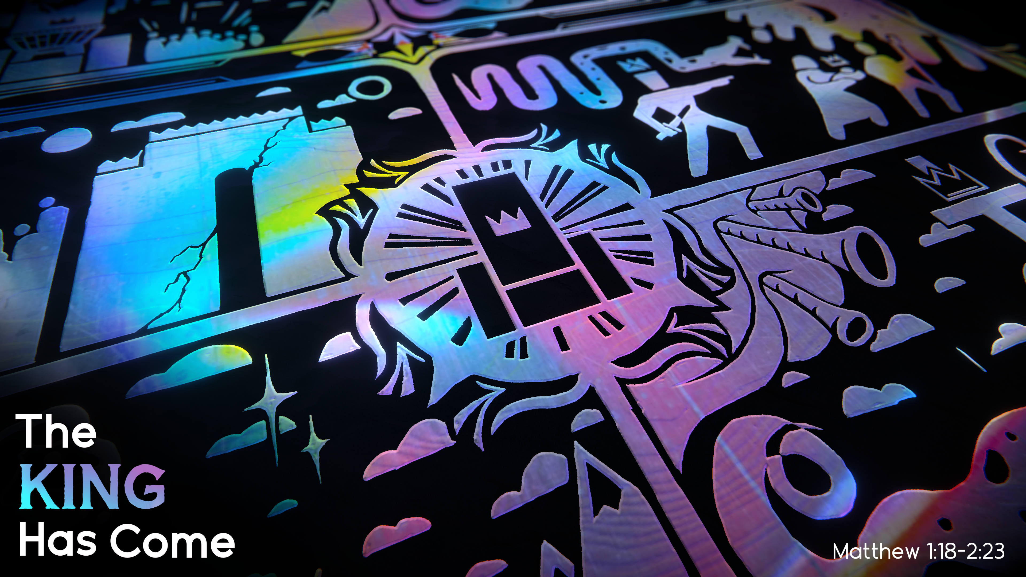
THE KING HAS COME
TRUE WORSHIP, PART 2
Matthew 2:7-12
Pastor Evan Jacobsen • Compass Bible Church Hill Country • November 13, 2022 • Msg. G22-07

Matthew 2:7-12
7 Then Herod summoned the wise men secretly and ascertained from them what time the star had appeared. 8 And he sent them to Bethlehem, saying, “Go and search diligently for the child, and when you have found him, bring me word, that I too may come and worship him.” 9 After listening to the king, they went on their way. And behold, the star that they had seen when it rose went before them until it came to rest over the place where the child was. 10 When they saw the star, they rejoiced exceedingly with great joy. 11 And going into the house, they saw the child with Mary his mother, and they fell down and worshiped him. Then, opening their treasures, they offered him gifts, gold and frankincense and myrrh. 12 And being warned in a dream not to return to Herod, they departed to their own country by another way. (ESV)

1. Demolish ___________________________ (vv.7-8)

2. See ______________________________ (vv.9-11)

3. Let ________________________________ (v.12)

Application Questions
These questions are provided for your further study and application of today’s sermon. Thoughtfully writing out the answers to these questions will help to drive home the point of today’s study. It is also helpful when you are able to discuss your answers with others. For more information about LifeGroups at Compass Bible Church that utilize these questions as the basis for their weekly discussion, please visit compasshillcountry.org/lifegroups or email us at info@compasshillcountry.org.

- Write down one observation you found particularly helpful from this week's sermon.
- Read Matthew 15:7-9 & Matthew 5:23–24. In what ways can you fall into the trap of improperly worshipping God?
  - Herod’s root of improper worship was his desire to be king. What desires do you have that can lead you away from properly worshipping God?
This Week’s
Bible Reading Schedule
November 13th
Ezekiel 4-6 & Heb 10:1-23
November 14th
Ezekiel 7-9 & Heb 10:24-39
November 15th
Ezekiel 10-12 & Heb 11:1-19
November 16th
Ezekiel 13-15 & Heb 11:20-40
November 17th
Ezekiel 16 & Hebrews 12
November 18th
Ezekiel 17-19 & Hebrews 13
November 19th
Ezekiel 20-21 & James 1
November 20th
Ezekiel 22-23 & James 2

- Read Matthew 2:10 & Psalm 84. How do these verses motivate you to have greater joy in Christ in your worship?
  - What specific rhythms can you have in your week that can help cultivate a deeper joy in Christ?
- Read Psalm 95:6 & Matthew 2:11. Why is it essential to come prepared to worship God? What can you start doing this week to prepare you for corporate worship on Sunday & at Life Group?
This Week’s Memory Verse
Hebrews 4:12-13 (ESV)
12 For the word of God is living and active, sharper than any two-edged sword, piercing to the division of soul and of spirit, of joints and of marrow, and discerning the thoughts and intentions of the heart. 13 And no creature is hidden from his sight, but all are naked and exposed to the eyes of him to whom we must give account.

See this sermon and all Compass-related videos on YouTube.com/CompassBibleChurchHillCountry
Subscribe to Weekend Sermons, Compass Equip & LifeGroup Leader Podcasts: CompassChurch.org/podcasts

