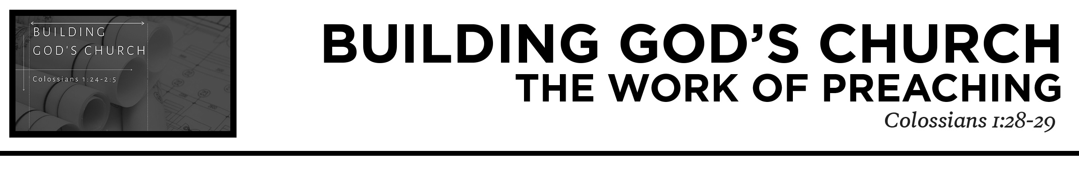

Pastor Hayden Thomas • Compass Bible Church Hill Country • November 7, 2021 • Msg. 21-22
Colossians 1:28-29
Him we proclaim, warning everyone and teaching everyone with all wisdom, that we may present everyone mature in Christ. 29 For this I toil, struggling with all his energy that he powerfully works within me. (ESV)

1. Make _________________________________
(v.28a)

2. Understand ____________________________
(v.28b)

3. Understand ____________________________
(v.28c)

4. Expend ________________________________
(v.29)

Application Questions
These questions are provided for your further study and application of today’s sermon. Thoughtfully writing out the answers to these questions will help to drive home the point of today’s study. It is also helpful when you are able to discuss your answers with others. For more information about LifeGroups at Compass Bible Church that utilize these questions as the basis for their weekly discussion, please visit compasshillcountry.org/lifegroups or email us at info@compasshillcountry.org.

1. Read 2 Corinthians 4:5 and 1 Corinthians 2:1-5. What can you take from Paul’s words in these two scriptures about the way in which you should present the gospel to others?

2. Read Matthew 28:19-20, Romans 15:14 and Colossians 1:28. What parts do warning (Noutheteō) and teaching play in evangelism and discipleship in the church? What are some problems that arise if these two parts are missing in the ministry of the church?

3. Colossians 1:28 makes the point that our work to “deliver people over to Christ” is part of the continued work that we as Christians get to participate in. How does this expectation heighten your attentiveness to the responsibility you have in the work of ministry this week?

4. Read Ephesians 4:11-13 and 2 Timothy 3:16-17. The Greek word for “Perfect” is used in these two verses to describe what God’s word does as the Spirit of God works in us. Why is claiming to be a Christian who does not continue maturing in their faith a non-biblical attitude? Can you find any other scriptures that describe how God matures Christians?

5. Read Colossians 4:12–13 and Philippians 1:27. How do these scriptures describe the way in which we should work to reach the lost? What are some actions you can take this week to work harder at proclaiming the gospel to lost souls?
This Week’s
Bible Reading Schedule
November 7th
Jer.46-48 & Heb.4
November 8th
Jer.49-50 & Heb.5
November 9th
Jer.51-52 & Heb.6
November 10th
Lam.1-2 & Heb.7
November 11th
Lam.3-5 & Heb.8
November 12th
Ezk.1-3 & Heb.9
November 13th
Ezk.4-6 & Heb.10:1-23
November 14th
Ezk.7-9 & Heb.10:24-39

