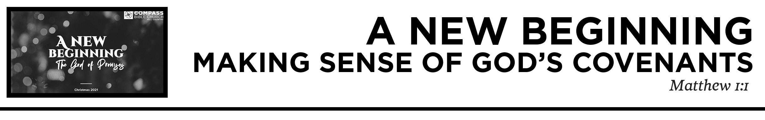

Pastor Hayden Thomas • Compass Bible Church Hill Country • December 5, 2021 • Msg. 21-25
Matthew 1:1-6a
1 The book of the genealogy of Jesus Christ, the son of David, the son of Abraham. 2 Abraham was the father of Isaac, and Isaac the father of Jacob, and Jacob the father of Judah and his brothers, 3 and Judah the father of Perez and Zerah by Tamar, and Perez the father of Hezron, and Hezron the father of Ram, 4 and Ram the father of Amminadab, and Amminadab the father of Nahshon, and Nahshon the father of Salmon, 5 and Salmon the father of Boaz by Rahab, and Boaz the father of Obed by Ruth, and Obed the father of Jesse, 6 and Jesse the father of David the king. And David was the father of Solomon by the wife of Uriah, (ESV)

1. Recognize _____________________________
(v.1c)

2. Look _________________________________
(v.1b)

3. Understand ___________________________
(v.1a)

Application Questions
These questions are provided for your further study and application of today’s sermon. Thoughtfully writing out the answers to these questions will help to drive home the point of today’s study. It is also helpful when you are able to discuss your answers with others. For more information about LifeGroups at Compass Bible Church that utilize these questions as the basis for their weekly discussion, please visit compasshillcountry.org/lifegroups or email us at info@compasshillcountry.org.

1. Read Jeremiah 31:31-34, Ezekiel 36:22-28 and 1 Corinthians 11:23-26. Why do you need Christmas? How can you begin rethinking your understanding of Christmas in light of the New Covenant, using these three verses?

2. Read Genesis 12:1-3, Genesis 15:3-5, and Revelation 7:9-10. How does better understanding God’s global redemptive plan get you motivated to participate in reaching the lost for Christ? Why is it important to see that God has made a way for every person in your sphere of influence to be saved by turning from their sins and trusting in Christ?

3. Read 2 Samuel 7:1–17. How do these verses point to Jesus as the ultimate fulfillment of God’s promise to David?

4. Read Luke 1:31–33. Why is there still much more to look forward to than the here and now as Christians, because of Jesus’ eternal reign?
This Week’s
Bible Reading Schedule
November 14th
Ezk.7-9 & Heb.10:24-39
November 15th
Ezk.10-12 & Heb.11:1-19
November 16th
Ezk.13-15 & Heb.11:20-40
November 17th
Ezk.16 & Heb.12
November 18th
Ezk.17-19 & Heb.13
November 19th
Ezk.20-21 & Jms.1
November 20th
Ezk.22-23 & Jms.2
November 21st
Ezk.24-26 & Jms.3

