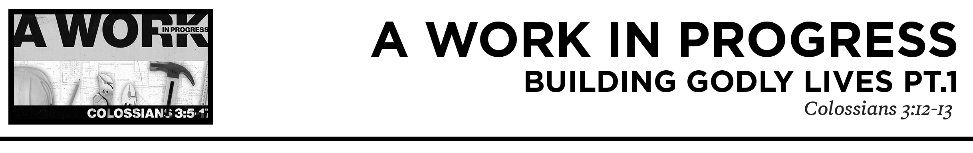

Pastor Hayden Thomas • Compass Bible Church Hill Country • February 20, 2022 • Msg. 22-08
Colossians 3:12-13
12 Put on then, as God’s chosen ones, holy and beloved, compassionate hearts, kindness, humility, meekness, and patience, 13 bearing with one another and, if one has a complaint against another, forgiving each other; as the Lord has forgiven you, so you also must forgive. (ESV)

1. Resolve ______________________________
(v.12)

2. Consider _____________________________
(v.13a)

3. Treat ________________________________
(v.13b)

Application Questions
These questions are provided for your further study and application of today’s sermon. Thoughtfully writing out the answers to these questions will help to drive home the point of today’s study. It is also helpful when you are able to discuss your answers with others. For more information about LifeGroups at Compass Bible Church that utilize these questions as the basis for their weekly discussion, please visit compasshillcountry.org/lifegroups or email us at info@compasshillcountry.org.

1. Read Exodus 34:6 and Nehemiah 9:16–21. What words are used here to describe the character of God? What are practical ways you can display these characteristics this week?

2. Read 2 Peter 3:9, Romans 2:4–5, and Romans 5:6–8. How does considering God’s forbearance toward your failures persuade you to more eagerly bear with the deficiency of others?

This Week’s Memory Verse
Mark 1:14-15
14 Now after John was arrested, Jesus came into Galilee, proclaiming the gospel of God, 15 and saying, “The time is fulfilled, and the kingdom of God is at hand; repent and believe in the gospel.”
Follow along with the Bible Memory App:
qrco.de/cbcbibleverse

3. Read Galatians 6:2 & Ephesians 4:1-6. What are common areas of conflict found in the church? How does the Bible instruct Christians to handle interpersonal conflict within the church? Write down another verse that shows how God’s church should resolve conflict.
This Week’s
Bible Reading Schedule
February 20th
Numbers 3-4 & Mk.3:22-35
February 21st
Numbers 5-6 & Mk 4:1-20
February 22nd
Numbers 7 & Mk.4:21-41
February 23rd
Numbers 8-10 & Mk.5:1-20
February 24th
Numbers 11-13 & Mk.5:21-43
February 25th
Numbers 14-15 & Mk.6:1-32
February 26th
Numbers 16-17 & Mk.6:33-56
February 27th
Numbers 18-20 & Mk.7:1-13

4. Read Isaiah 53:4–6 & Colossians 3:13. How do these passages motivate you to forgive others who have wronged you? Is there anyone in God’s church you need to extend forgiveness to this week? Is there anyone in God’s church you need to seek forgiveness from?

See this sermon and all
Compass-related videos on YouTube.com/
CompassBibleChurchHillCountry
Subscribe to Weekend Sermons, Compass Equip & LifeGroup Leader Podcasts:
CompassChurch.org/podcasts

