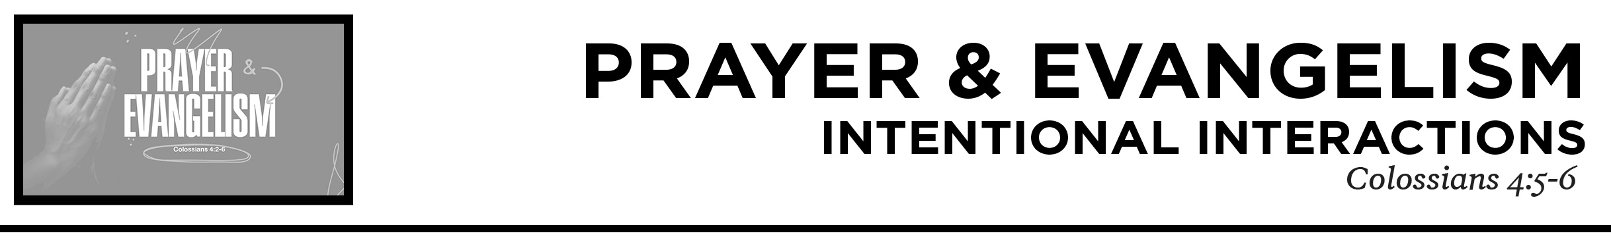

Pastor Hayden Thomas • Compass Bible Church Hill Country • May 8, 2022 • Msg. 22-18
Colossians 4:5-6
5 Walk in wisdom toward outsiders, making the best use of the time. 6 Let your speech always be gracious, seasoned with salt, so that you may know how you ought to answer each person. (ESV)

1. Live ________________________________(v.5)

2. Speak ______________________________ (v.6)

Application Questions
These questions are provided for your further study and application of today’s sermon. Thoughtfully writing out the answers to these questions will help to drive home the point of today’s study. It is also helpful when you are able to discuss your answers with others. For more information about LifeGroups at Compass Bible Church that utilize these questions as the basis for their weekly discussion, please visit compasshillcountry.org/lifegroups or email us at info@compasshillcountry.org.

1. Write down an observation or application you took away from this week’s sermon.

2. Read Matthew 10:16 and Ephesians 5:15-17. What does living with intent and wisdom look like for Christians? What is the danger of halfheartedly living out your faith with no gospel intentions?
This Week’s Memory Verse
Luke 24:46-47
and said to them, “Thus it is written, that the Christ should suffer and on the third day rise from the dead, and that repentance for the forgiveness of sins should be proclaimed in his name to all nations, beginning from Jerusalem. (ESV)

3. Read Acts 8:32–35 and Romans 10:14–17. Why is proclaiming the gospel verbally necessary to win souls to Christ? What are a few ways you can “season your speech with salt” to make sure the gospel is presented tactfully?
This Week’s
Bible Reading Schedule
May 8th
1 Kings 16-18 & John 1:29-51
May 9th
1 Kings 19-20 & John 2
May 10th
1 Kings 21-22 & John 3:1-21
May 11th
2 Kings 1-3 & John 3:22-36
May 12th
2 Kings 4-5 & John 4:1-30
May 13th
2 Kings 6-8 & John 4:31-54
May 14th
2 Kings 9-11 & John 5:1-24
May 15th
2 Kings 12-14 & John 5:25-47

4. Read 1 Corinthians 9:19–22 and Colossians 4:6. How do these verses describe some of the necessary elements for intentional interactions with non-Christians, for the sake of winning souls to Christ?

See this sermon and all
Compass-related videos on YouTube.com/
CompassBibleChurchHillCountry
Subscribe to Weekend Sermons, Compass Equip & LifeGroup Leader Podcasts:
CompassChurch.org/podcasts

