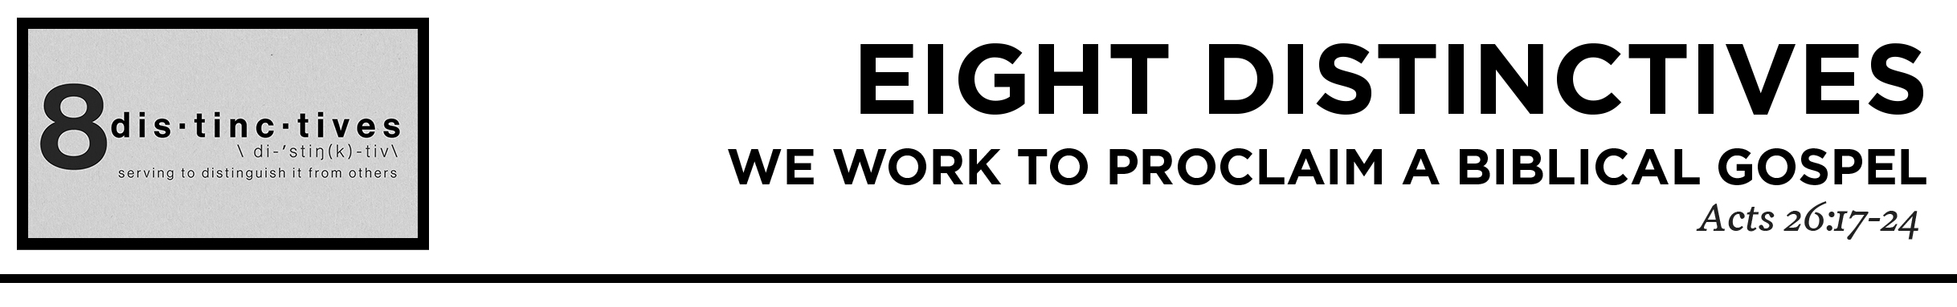

Pastor Hayden Thomas • Compass Bible Church Hill Country • July 18, 2021 • Msg. 21-06
Acts 26:17-24 delivering you from your people and from the Gentiles—to whom I am sending you 18 to open their eyes, so that they may turn from darkness to light and from the power of Satan to God, that they may receive forgiveness of sins and a place among those who are sanctified by faith in me.’ 19 “Therefore, O King Agrippa, I was not disobedient to the heavenly vision, 20 but declared first to those in Damascus, then in Jerusalem and throughout all the region of Judea, and also to the Gentiles, that they should repent and turn to God, performing deeds in keeping with their repentance. 21 For this reason the Jews seized me in the temple and tried to kill me. 22 To this day I have had the help that comes from God, and so I stand here testifying both to small and great, saying nothing but what the prophets and Moses said would come to pass: 23 that the Christ must suffer and that, by being the first to rise from the dead, he would proclaim light both to our people and to the Gentiles.” 24 And as he was saying these things in his defense, Festus said with a loud voice, “Paul, you are out of your mind; your great learning is driving you out of your mind.” (ESV)

1. Come ________________________________
(vv.18,23)

2. Rightly _______________________________
(vv.18b,20b)

3. Get _________________________________
(vv.17b,19b-20a,22)

Application Questions
These questions are provided for your further study and application of today’s sermon. Thoughtfully writing out the answers to these questions will help to drive home the point of today’s study. It is also helpful when you are able to discuss your answers with others. For more information about LifeGroups at Compass Bible Church that utilize these questions as the basis for their weekly discussion, please visit compasshillcountry.org/lifegroups or email us at info@compasshillcountry.org.

1. Read 2 Corinthians 5:20 and 2 Timothy 2:15. Take time now to write down the Biblical gospel and prepare to share the gospel to your LifeGroup. (pick 2-3 people to share.)

2. Read Romans 1:16 and 1 Corinthians 2:2. What are some of the temptations of adding something else appealing to the gospel? How have these same additions mislead so many away from a Biblical gospel?

3. Read Galatians 1:6–9. What are some of the prevalent false gospels in our culture and how can you better sniff out false gospels not only in our society, but the false gospel that can be evident in your own life?

4. Read Mark 16:15 and Acts 1:8. How will you get serious about the mission of the gospel this week? give examples.

This Week’s
Bible Reading Schedule
July 18th
Ps.25-27 & Ac.20:17-38
July 19th
Ps.28-30 & Ac.21:1-14
July 20th
Ps.31-33 & Ac.21:5-40
July 21st
Ps.34-35 & Ac.22
July 22nd
Ps.36-37 & Ac.23:1-11
July 23rd
Ps.38-40 & Ac.23:12-35
July 24th
Ps.41-43 & Ac.24
July 25th
Ps.44-46 & Ac.25

