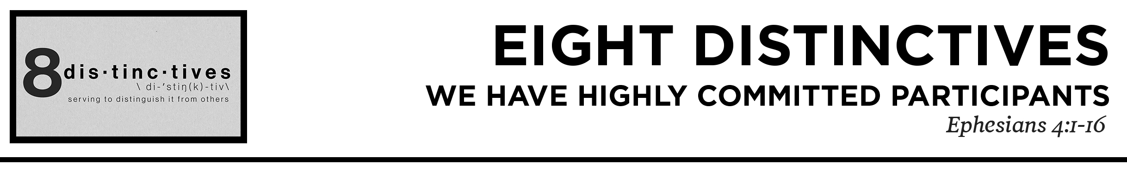

Pastor Hayden Thomas • Compass Bible Church Hill Country • August 1, 2021 • Msg. 21-08
Ephesians 4:1-16
I therefore, a prisoner for the Lord, urge you to walk in a manner worthy of the calling to which you have been called, 2 with all humility and gentleness, with patience, bearing with one another in love, 3 eager to maintain the unity of the Spirit in the bond of peace. 4 There is one body and one Spirit—just as you were called to the one hope that belongs to your call— 5 one Lord, one faith, one baptism, 6 one God and Father of all, who is over all and through all and in all. 7 But grace was given to each one of us according to the measure of Christ’s gift. 8 Therefore it says, “When he ascended on high he led a host of captives, and he gave gifts to men.” 9 (In saying, “He ascended,” what does it mean but that he had also descended into the lower regions, the earth? 10 He who descended is the one who also ascended far above all the heavens, that he might fill all things.) 11 And he gave the apostles, the prophets, the evangelists, the shepherds and teachers, 12 to equip the saints for the work of ministry, for building up the body of Christ, 13 until we all attain to the unity of the faith and of the knowledge of the Son of God, to mature manhood, to the measure of the stature of the fullness of Christ, 14 so that we may no longer be children, tossed to and fro by the waves and carried about by every wind of doctrine, by human cunning, by craftiness in deceitful schemes. 15 Rather, speaking the truth in love, we are to grow up in every way into him who is the head, into Christ, 16 from whom the whole body, joined and held together by every joint with which it is equipped, when each part is working properly, makes the body grow so that it builds itself up in love. (ESV)

1. Commit ______________________________
(vv.1-6)

2. Appreciate ___________________________
(v.7)

3. See _________________________________
(vv.8-10)

4. Recognize____________________________
(v.11)

5. Engage ______________________________
(vv.12-14)

6. Let’s ________________________________
(vv.15-16)

Application Questions
These questions are provided for your further study and application of today’s sermon. Thoughtfully writing out the answers to these questions will help to drive home the point of today’s study. It is also helpful when you are able to discuss your answers with others. For more information about LifeGroups at Compass Bible Church that utilize these questions as the basis for their weekly discussion, please visit compasshillcountry.org/lifegroups or email us at info@compasshillcountry.org.

1. Read Ephesians 2:18-22. Paul solidifies what God’s family plan looks like in these five verses. What are some of the key components in these verses for our church to imitate in order to obey what God expects for His family?

2. Read Philippians 2:2 and 1 Corinthians 1:10. Consider God’s household rules. Now consider your own household. Why is unity so important for your home to function properly? Likewise, how would the church suffer if there is a lack of unity?

3. Read 1 Corinthians 12:4–7 and 1 Peter 4:10. Understanding first that everyone in God’s household has been given gifts to serve God’s family, what is the impact for a church who’s people do not use their abilities to serve? On the other hand, what is the impact for a church who’s people use their gifts to serve God and his church?

4. Read 1 Thessalonians 5:12–13 and Hebrews 13:17. Seeing your Pastors as a gift to the church is biblical and prudent. Biblically speaking what does it look like to see your church leaders as gifts?

5. Read Matthew 28:18-20 and 1 Corinthians 4:1. The ministry of the church is two fold. first, to build up the church and secondly, to reach lost souls with the gospel. Of course there is considerable overlap in these two categories, but they each have their own distinct functions. What are the benefits of noticing the two pronged aspects of church work and participating in both?
This Week’s
Bible Reading Schedule
August 1st
Ps.65-67 & Ro.2
August 2nd
Ps.68-69 & Ro.3
August 3rd
Ps.70-72 & Ro.4
August 4th
Ps.73-74 & Ro.5
August 5th
Ps.75-77 & Ro.6
August 6th
Ps.78 & Ro.7
August 7th
Ps.79-81 & Ro.8:1-18
August 8th
Ps.82-84 & Ro.8:19-39

