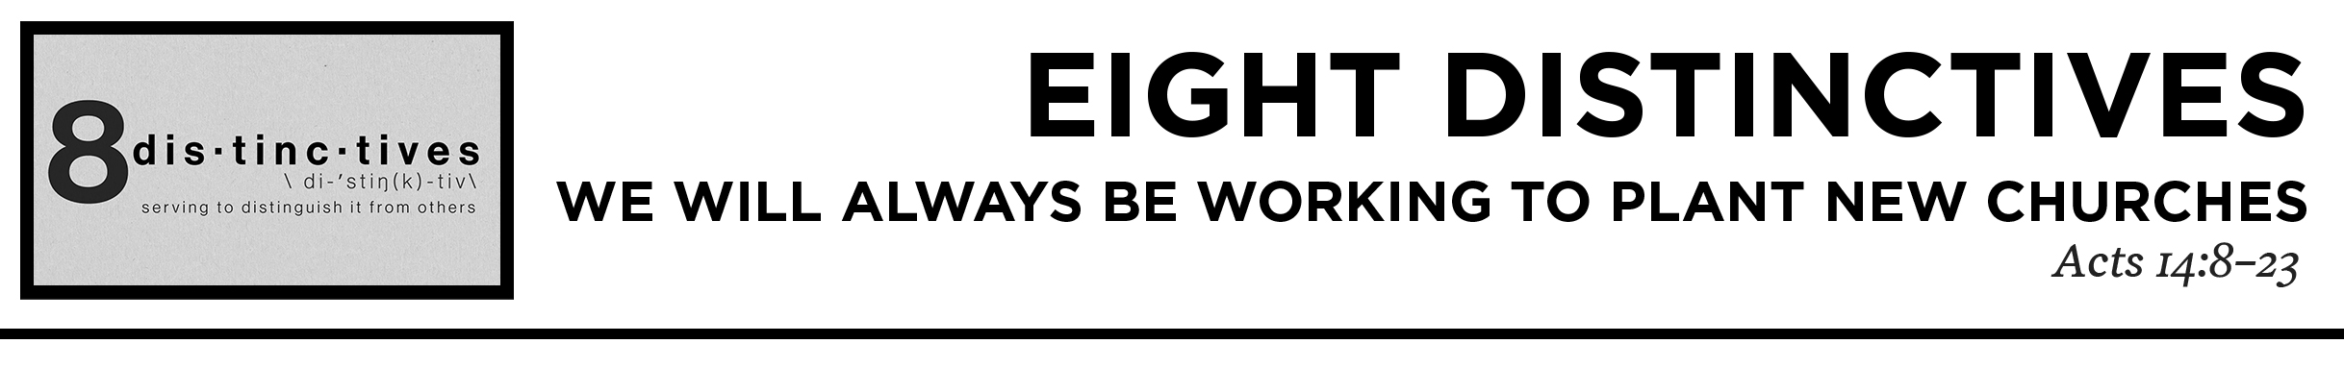

Pastor Hayden Thomas • Compass Bible Church Hill Country • August 22, 2021 • Msg. 21-11
Acts 14:8-23
Now at Lystra there was a man sitting who could not use his feet. He was crippled from birth and had never walked. 9 He listened to Paul speaking. And Paul, looking intently at him and seeing that he had faith to be made well, 10 said in a loud voice, “Stand upright on your feet.” And he sprang up and began walking. 11 And when the crowds saw what Paul had done, they lifted up their voices, saying in Lycaonian, “The gods have come down to us in the likeness of men!” 12 Barnabas they called Zeus, and Paul, Hermes, because he was the chief speaker. 13 And the priest of Zeus, whose temple was at the entrance to the city, brought oxen and garlands to the gates and wanted to offer sacrifice with the crowds. 14 But when the apostles Barnabas and Paul heard of it, they tore their garments and rushed out into the crowd, crying out, 15 “Men, why are you doing these things? We also are men, of like nature with you, and we bring you good news, that you should turn from these vain things to a living God, who made the heaven and the earth and the sea and all that is in them. 16 In past generations he allowed all the nations to walk in their own ways. 17 Yet he did not leave himself without witness, for he did good by giving you rains from heaven and fruitful seasons, satisfying your hearts with food and gladness.” 18 Even with these words they scarcely restrained the people from offering sacrifice to them. 19 But Jews came from Antioch and Iconium, and having persuaded the crowds, they stoned Paul and dragged him out of the city, supposing that he was dead. 20 But when the disciples gathered about him, he rose up and entered the city, and on the next day he went on with Barnabas to Derbe. 21 When they had preached the gospel to that city and had made many disciples, they returned to Lystra and to Iconium and to Antioch, 22 strengthening the souls of the disciples, encouraging them to continue in the faith, and saying that through many tribulations we must enter the kingdom of God. 23 And when they had appointed elders for them in every church, with prayer and fasting they committed them to the Lord in whom they had believed. (ESV)

1. Beware ______________________________
(vv.8-13)

2. Have ________________________________
(vv.14-18)

3. Maintain ______________________________
(vv.19-23)

Application Questions
These questions are provided for your further study and application of today’s sermon. Thoughtfully writing out the answers to these questions will help to drive home the point of today’s study. It is also helpful when you are able to discuss your answers with others. For more information about LifeGroups at Compass Bible Church that utilize these questions as the basis for their weekly discussion, please visit compasshillcountry.org/lifegroups or email us at info@compasshillcountry.org.

1. Read 1 Corinthians 3:3-9. How can losing the battle with your own flesh keep you from being an effective tool for God to help build his church? Why is maintaining a high view of God imperative if you truly desire to be useful to God?

2. Read Romans 9:1–3 and Romans 10:1. Do you find it difficult to have a burden for lost souls? How can you heighten your own desire for those who have never responded to the good news of the gospel?

3. Read Luke 15:8–10 and 1 Thessalonians 2:1–2. Conflict and persecution are sure to come in various ways as you commit to carrying out the mission of God to reach people for Christ, teach people to be like Christ, and train people to serve Christ. How do these verses motivate you to use your short time on Earth for the advancement of the gospel?

4. Matthew 16:13–18 and Revelation 21:5–8. What are some encouragements you gain from these scriptures that paint a vivid picture of Christ Triumphant church and your part in it?

This Week’s
Bible Reading Schedule
August 22nd
Ps.119:49-104 & 1Cor.4
August 23rd
Ps.119:105-176 & 1Cor.5
August 24th
Ps.120-123 & 1Cor.6
August 25th
Ps.124-127 & 1Cor.7:1-24
August 26th
Ps.128-131 & 1Cor.7:25-40
August 27th
Ps.132-135 & 1Cor.8
August 28th
Ps.136-138 & 1Cor.9
August 29th
Ps.139-141 & 1Cor.10:1-13

